* 1. **Introduction to Neural Networks**:
  + Neural networks are computational models inspired by the structure and function of biological neural networks in the human brain.
  + They are designed to learn patterns and relationships from data and make predictions or decisions based on that learned knowledge.

1. **Simple Neural Network**:
   * In the context of a housing price prediction example, a simple neural network consists of a **single neuron**.
   * Neurons receive inputs (such as the size of a house) and apply a mathematical operation to produce an output (such as the predicted price).
2. **Rectified Linear Units (ReLU)**:
   * The ReLU function is commonly used in neural networks to **introduce non-linearity and ensure that predictions are non-negative.**
   * It replaces **negative values with zero, effectively "rectifying" the linear portion of the function.**
3. **Building Larger Neural Networks**:
   * Larger neural networks are created by stacking multiple neurons together.
   * Each neuron processes different features, allowing the network to capture complex relationships between inputs and outputs.
4. **Multiple Features Example**:
   * An example scenario involves predicting house prices based on various features beyond just house size.
   * These features might include the number of bedrooms, zip code (indicating walkability), and neighborhood wealth (indicating school quality).

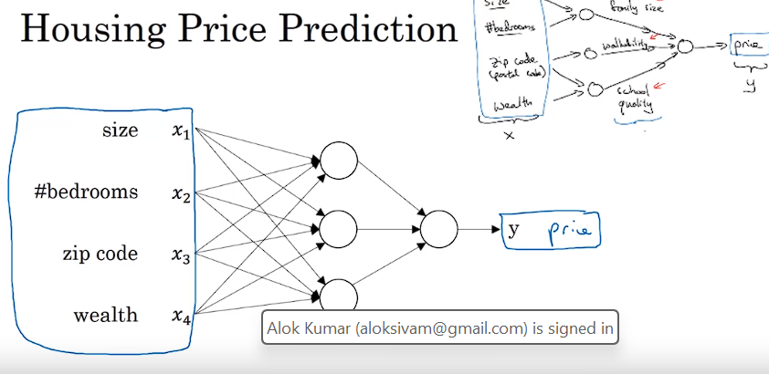

1. **Training Neural Networks**:
   * Neural networks learn to map inputs to outputs through a process called training, where they adjust their internal parameters based on examples from a training dataset.
   * Hidden units in the network process inputs and learn to make predictions through repeated exposure to training data.
2. **Dense Connectivity**:
   * In a densely connected layer, each input feature is connected to every neuron in the hidden layer.
   * This allows the network to learn complex relationships between input features and predictions by considering all possible interactions.
3. **Supervised Learning with Neural Networks**:
   * Supervised learning is a common paradigm where neural networks are trained to predict outputs from inputs.
   * In the housing price prediction example, the network is trained with input-output pairs, learning to predict prices based on given features.
   1. **Supervised Learning with Neural Networks**:
   * Supervised learning involves learning a function that maps inputs (x) to outputs (y) based on labeled training data.
   * Examples include **predicting house prices based on features of a home and predicting ad clicks based on ad information and user data.**
   * 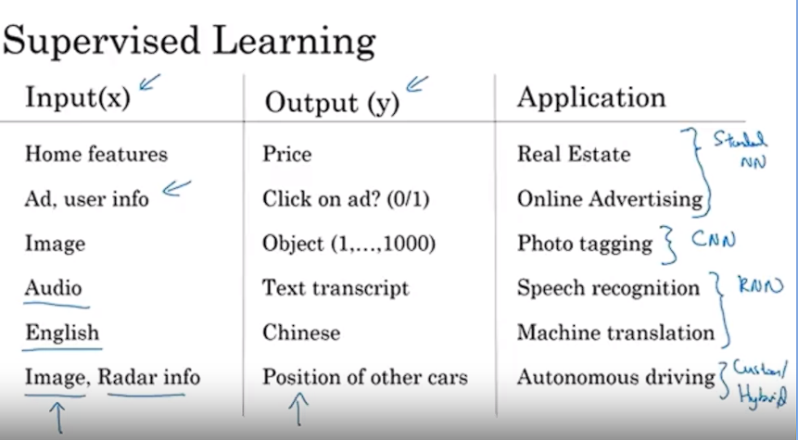
4. **Structured vs. Unstructured Data**:
   * Structured data refers to well-defined data with clear features, **often found in databases.**
   * Unstructured data includes raw **audio, images, or text, where features are not as clearly defined.**
   * Historically, it was harder for computers to interpret unstructured data, but neural networks have greatly improved this capability.
5. **Economic Value Creation**:
   * Neural networks have created significant economic value, particularly in improving advertising systems, profit recommendations, and database processing.
   * Their ability to interpret both structured and unstructured data has contributed to this value creation.
6. **Transformation of Supervised Learning**:
   * Neural networks have transformed supervised learning by significantly improving performance in various tasks.
   * While the basic ideas behind neural networks have been around for decades, recent advancements in technology and methodology have led to their widespread adoption and effectiveness.
   1. **The Rise of Deep Learning**:

Despite the longstanding existence of deep learning concepts, its recent effectiveness can be attributed to several key factors.

1. **Data and Performance**:
   1. The availability of vast amounts of data has been crucial. Traditional learning **algorithms may plateau in performance as data increases, but neural networks, especially larger ones, continue to improve with more data.**
   2. Digitization of society has led to an exponential increase in data collection, thanks to activities conducted on digital platforms and the proliferation of sensors in various devices. 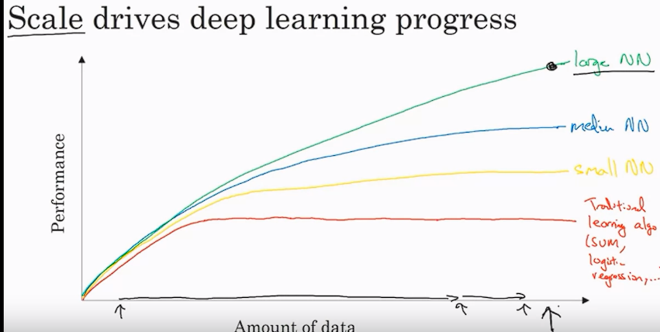
2. **Scale and Performance**:
   1. Scale, referring to **both the size of neural networks and the amount of data, has been a driving force behind deep learning progress.**
   2. Larger neural networks tend to perform better, but they **require substantial amounts of data to train effectively.**
3. **Algorithmic Innovation**:
   1. While scale and data have played significant roles, algorithmic innovation has also been crucial.
   2. Innovations such as using rectified linear units (ReLU) instead of sigmoid functions have greatly **improved the efficiency of neural network training.**

Using Rectified Linear Unit (ReLU) activation functions instead of sigmoid functions in neural networks offers several advantages:

1. **Avoids Vanishing Gradient**: ReLU prevents the vanishing gradient problem, ensuring faster learning, especially in deep networks.
2. **Efficient Computation**: ReLU is computationally simpler and faster compared to sigmoid.
3. **Sparse Activation**: ReLU induces sparsity in activations, leading to more efficient representation of data and reduced overfitting.
4. **Improved Gradient Flow**: ReLU provides non-saturating gradients, facilitating **better gradient flow during training.**
5. **Address Saturation Issue**: ReLU does not saturate in the positive direction, allowing for continued learning even for large inputs.
6. **Faster Convergence**: ReLU often leads to faster convergence during training compared to sigmoid functions.
7. **Fast Computation**:
   1. Fast computation is essential for rapid experimentation and iteration in neural network development.
   2. Improved computational speed allows researchers and practitioners to try out more ideas and refine their neural network architectures more quickly.
8. **Impact on Research Community**:
   1. These advancements have accelerated progress not only for practitioners but also for researchers in the deep learning community.
   2. Faster iteration cycles have led to continuous improvement in algorithms and methodologies.
9. **Continued Progress**:
   1. The forces driving the rise of deep learning, including data availability, computational advancements, and ongoing algorithmic innovation, continue to strengthen.
   2. Optimism remains high for the future of deep learning, with expectations of further advancements in performance and applicability.

